Technical Research Guide

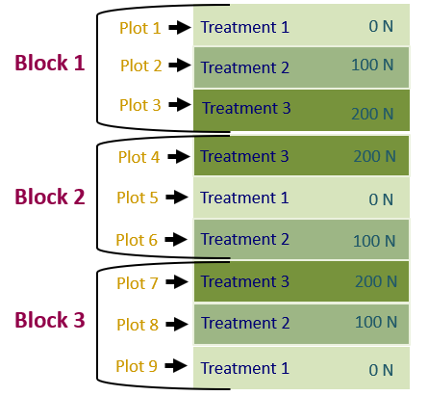
Research terminology

- Replicate: repeating treatment
- Block: repeating treatments grouped together
  - Blocks allow for ease in sampling and data organization/analysis.
  - Blocking may not be possible for all experiments due to field shape/size. All treatments may then be completely randomized.
- Treatment: strip that management is applied to
- Plot: Each unique strip, only occurs once for each project
Figure 1. Plot design with labeled research terminology.

Research design requirements
Some projects might not be able to meet these requirements due to equipment size, fertigation patterns, long term crop impacts, etc. Contact Monica or Lindsey to work around any specific issues and develop a viable research project.

Replication
Definition- Repeating experimental treatments across conditions. For example, if a research project has 4 nitrogen rates, these rates would need to be repeated or replicated 4 times across the field.
Why- Replication within a research project identifies if a specific result is true or not. If the same result is seen across multiple plots over the variation within a field, it is less likely that this result is due to chance.

Randomization
Definition- The process of making something random. For this program, treatment location (N rate in most cases) across the field should be randomized.
Why- Randomization aids in ensuring that any result we see is due to the variable we are measuring rather than another underlying variable.
How- Randomization can be done in many ways, from pulling numbers from a hat to online number generators. The website: https://www.randomizer.org/ works well for randomizing plots.

Four nitrogen rates
NOPP projects must have four nitrogen rate treatments to quantify nitrogen optimization. These rates should be zero N, close to “business as usual” (BAU), and a rate both above and below BAU. For example, if corn on the project field usually receives 160 lb-N/ac, your project N rates could be 0, 75, 150, and 225 lbs-N/ac. While four nitrogen rates is the requirement, including more N rates will allow for more accurate calculation of optimum nitrogen rates.

Zero N strip
A zero N rate is necessary for measuring the soil’s ability to supply N to the crop and calculate potentially leachable nitrogen. Small amounts of N in starter fertilizer or other fertility amendments is allowed but must be recorded as annual N inputs.

Required sampling
Soil samples at the 0-1’ & 1-2’ depth are required to capture nitrate in the soil profile. Nitrate readily moves through the soil profile with water, so it is essential to capture the second foot. This sampling is easier to collect using a “backsaver” soil probe rather than a traditional probe. The “backsaver” probe has an extendable rod that allows you to pull soil samples down to 46 inches without bending over. We recommend applicants build some sort of extendable probe into their budget to complete this sampling.
Instructional sampling video: https://www.youtube.com/watch?v=vfMG6qr9Xoc).
Link to commonly used extendable probe: https://www.jmcsoil.com/PN001-PT-SM-JMC-Backsaver-Handle-with-Sampling-Tube

The scale that each sample is taken will be project dependent, but generally sampling should be done at this frequency:
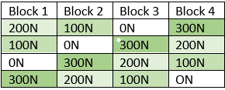
- Routine soil analysis- Sample at the block scale before any management is completed on the field. Figure 1 highlights which areas would be included in the block sampling pattern. Representative soil cores would be pulled from each block (outlined in purple dashes), for a total of four composite samples for the field.
Figure 2. Plot design with block sampling pattern outlined in purple dashes.
- Pre-plant or pre-sidedress soil test nitrate (0-1’ & 1-2’)- Sampling at the plot level will provide the most accurate results to capture any variation in the field. In a project design similar to Figure 2, this would equate to 16 total samples for the project. If you are unable to sample at this scale, sampling at the block level would suffice. Sampling at the block level according to the design in Figure 2 would result in 4 samples for the project.
- Post harvest soil test nitrate (0-1’ & 1-2’)- Sampling must be done at the plot level for any soil nitrate samples taken after nitrogen fertilizer is put out.
- Cover crop biomass (if applicable)- If planted on the entire field, collect one composite sample composed of biomass from across the field. If cover crops area variable being tested in the study, collect one sample for each cover crop strip or treatment.
- Manure (if applicable)- Collect sample directly from manure load being applied to the field for best accuracy. If this is not possible, a daily load sample will suffice. https://uwlab.soils.wisc.edu/wp-content/uploads/sites/17/2022/02/Manure-Info-Sheet-0122.pdf
Project examples
- Nitrogen rate field study: The goal of a nitrogen rate study is to identify the optimum N rate that sustains soil fertility and crop production. This can be done by using four nitrogen rate treatments (as mentioned above). This will provide information both relative to the field, but also collectively contributing to greater knowledge of factors that might impact N rates. The way this looks can vary depending on the field, but be sure to think about size of fertilizer applicator and harvest equipment when designing plots:
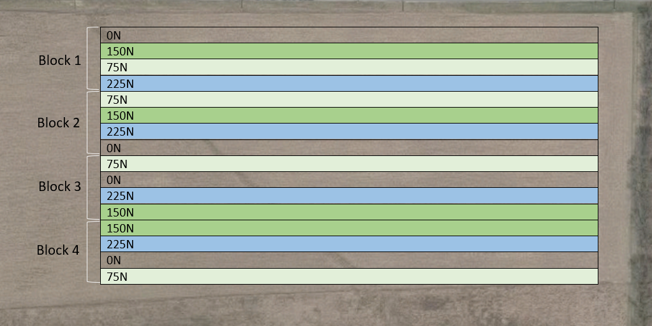

Layout 1- Randomized complete block design. Nitrogen rate strip study plot design with four N rates and four replications. This plot design example utilizes full field plot strips organized into blocks.
Block 1 | Block 2 | Block 3 | Block 4
200N | 100N | 0N | 300N
100N | 0N | 300N | 200N
0N | 300N | 200N | 100N
300N | 200N | 100N | ON

Layout 2- Randomized complete block design. Nitrogen rate study plot design with four N rates and four replications, utilizing randomization organized into blocks. Plots are smaller than the full field strips in layout 1, but still includes all design elements. Plot plan derived using MS word table.
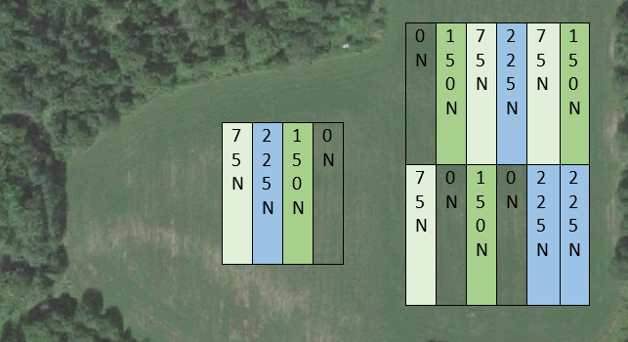
Layout 3. Nitrogen rate study plot design with four N rates and four replications with randomization. Blocking is not utilized in this example plot layout due to field shape, and this plan is completely acceptable. Plot plan derived using MS word table overlayed a google map screenshot.

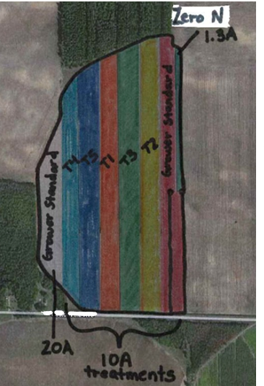

Layout 4. Nitrogen rate study plot design with seven randomized N rates but no true replication due to equipment/irrigation restrictions. Within each treatment strip, required sampling would need to be done at four points to act as replication across the field. Treatment strips are large to make up for this lack of true replication.

- Management interactions with N rate study: The goal of the study is to compare how different management practices influence the optimal N rate. This study will consist of the N rates mentioned above in example A, with the addition of a single management practice of their choosing to the study design. Proper controls need to exist for the management practice. For example, if cover crop is the added variable, no cover crop is the control. The applicant must explain why they believe the management practice they propose to study will change the optimal N application rate. Applicants are free to study any management practice they believe will change the optimal N rate including, but not limited to:

- Tillage | - N application timing
- Use of cover crops | - N source, N additives, or alternative products
- Use of manure | - Irrigation impacts
- N Placement – surface vs. Injection | - Alternative crop/forage systems not in A2809
- Managed grazing | - Grazing cover crops

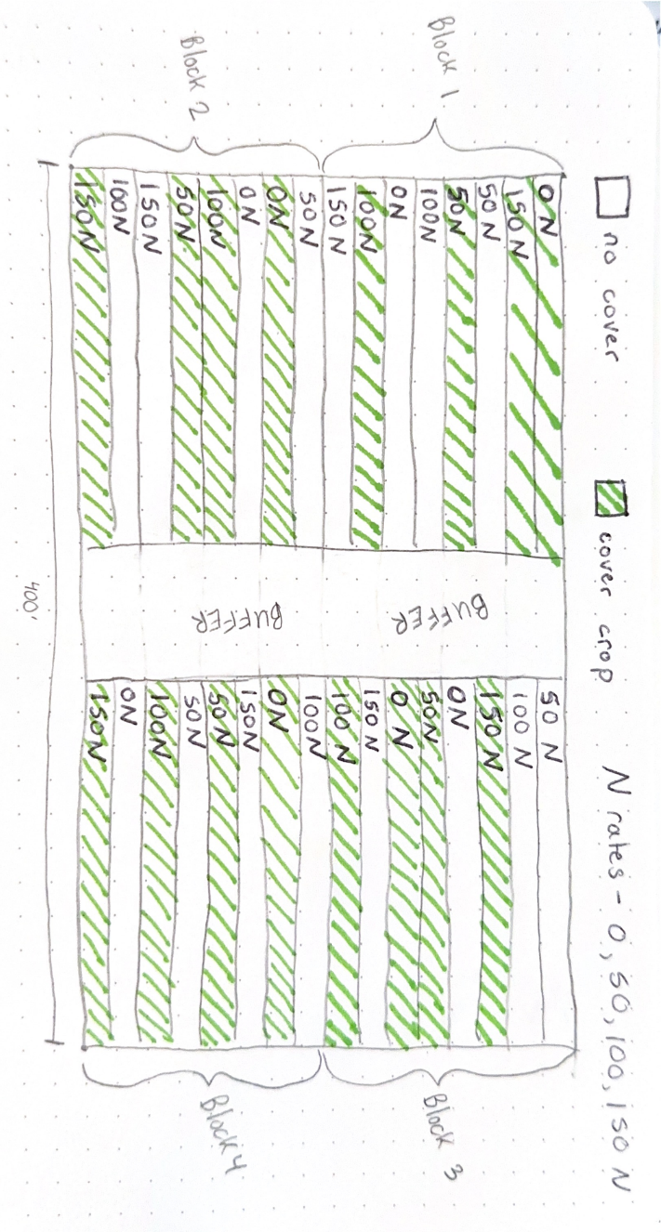

Layout 5- Randomized complete block design, split plot. Plot design of a cover crop interaction with N rate study with complete randomization and replication. Green dashes represent strips with cover crops and blank strips are no cover. Four replicates for each cover and nitrogen rate treatment are organized in each block. Buffer included between sections for adjusting equiptment for planting cover and/or fertilizing. Plot plan hand sketched.

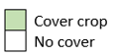
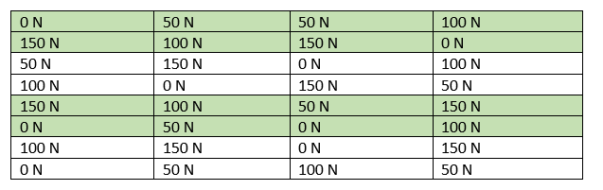

Layout 6- Complete block design, split plot. Cover crop interaction with N rate study with replication but not full randomization. This design is an option if the management interaction (in this case cover crop) cannot be fully randomized across the plots due to planting equipment. In this example, green highlighted plots represent a cover crop planted in two strips across the field. Blocks are indicated by dashed purple lines.

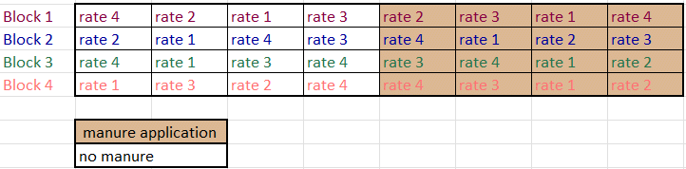

Layout 7- Complete block design, split plot. Manure application interaction with N rate study. Brown shaded plots indicate where manure is applied. While designs depicted in layout 5 and 6 would be preferred, this design is an option if the management factor application cannot be fine-tuned into a strip. Nitrogen rates are randomized, but manure application is not. While the data is more accurate statistically with full randomization, we can still gather valuable information from a project like this if true randomization cannot be met due to equipment/space restrictions.

- Advanced self-design option: Applicants who have experience or are comfortable with on-farm research are eligible to propose a nitrogen optimization study of their own design. These projects must include data collection requirements outlined in the RFP and should aim to meet all research design requirements. Applicants can choose to expand the nutrient data collection requirements of their study to include edge of field runoff, groundwater or lysimeter monitoring, or monitoring of nitrogen uptake in natural, restored, or constructed wetlands.

Contact Monica Schauer with questions in developing a sampling plan and plot design.

Monica Schauer
NOPP Research Director
(920) 296-6170
Monica.Schauer@wisc.edu

As stated in the application and RFP, the research design and plan must be approved by UW before submitting the final application. While these projects can be unique and contain a lot of detail, UW is committed to helping develop a research plan to provide valuable data to answer farm or regionally specific questions.

