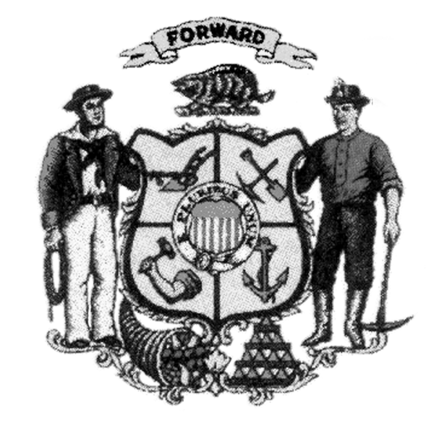
Land and Water Conservation Board
County Land and Water Resource Management Plan
Review of LWRM Plan Revisions
County:

Implementation Covering Past Five Years and Future Directions

Answer these four questions in writing (not to exceed 4 pages)

- Provide a representative number of accomplishments within the last five years that can be directly traced to activities identified in multiple work plans. For each accomplishment, explain how the planning process helped the county achieve its outcome, including planning adjustments that helped better target county activities.

- Identify any areas where the county was unable to make desired progress in implementing activities identified in recent work plans. For each area identified, explain the work plan adjustments that were made to refocus planned activities. If no areas are identified, explain how the county was able to make progress in all the areas planned.

- Describe the county’s approach to implementation of its priority farm strategy including outreach, farm inventories and making use of multiple funding sources. How has the county evaluated the effectiveness of its priority farm strategy and used this information to improve implementation of the agricultural performance standards and conservation practices on farms?

- Provide representative examples that show changes in direction in the county’s LWRM plan and annual work plans, with specific examples provided showing adjustments in goals, objectives or planned activities.

Annual Work Plans

Attach both of the following:

- The most current annual work plan, prepared in the current format from DATCP, and addresses all required items such as needed funding and staff hours.

- The work plan for the previous year that includes a column that identifies the progress in implementing the planned activities for that year.

Presentation Regarding County Resource Concerns

Prepare and present an 8-10 minute snapshot to the board regarding county resources and management issues. The county must prepare one of following as part of this brief presentation:
- A PowerPoint (showing what your county looks like, can include maps), or
- A hand out (2 page max)

Guidance on Board Review Process

The LWCB’s review supplements, but does not replace compliance with the DATCP checklist for LWRM plan approval. This encourages and supports honest presentations from the county. The county is strongly encouraged to have the LCC chair or committee member be a part of the presentation to the Board to contribute policy and other insights to the discussion. The goal of the review is not to fail counties. The board recognizes the dynamic nature of the planning process. Board members are interested in how counties tackle priorities over time and how they respond to changing conditions in pursuing their priorities. The board will evaluate a county’s planning and implementation based on how well the county balances and prioritizes the following: agricultural performance standards, other state priorities (impaired waters, FPP checks), and local priorities. When needed, the Board will provide constructive support to counties to improve the quality of their planning.

Land Conservation Committee Notification

The LCC was provided a completed copy of this form (including attachments) on:

Signature of Authorized Representative: __________________________Date: __________
(e.g. County Conservationist, LCC chair)

Send completed form and attachments to:
Lisa.Trumble@wi.gov

